Stock Market Analysis
Ananya Mukherjee

- MySQL : Inside the database “BDHS_PROJECT” we have the two tables(STOCK_COMPANIES and STOCK_PRICES) which will be used for analysis .
use BDHS_PROJECT;
SHOW TABLES;
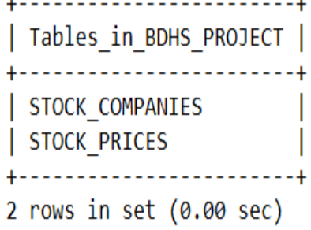

Let us have a quick view at the datasets

select * from STOCK_COMPANIES limit 5;
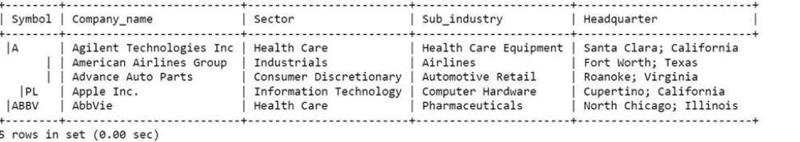

select * from STOCK_PRICES limit 5;
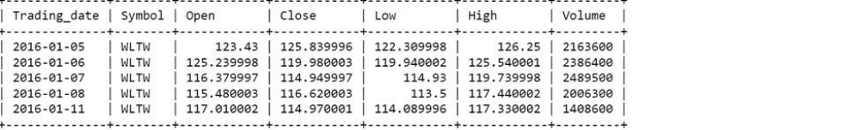

- Sqoop : We create a data pipeline using sqoop to pull the data from the MySQL server into Hive.

sqoop import --connect jdbc:mysql://ip-10-0-1-10.ec2.internal/BDHS_PROJECT --username labuser -password simplilearn --table Stock_companies –hive-import -hive-database stock_db --m 1
sqoop import --connect jdbc:mysql://ip-10-0-1-10.ec2.internal/BDHS_PROJECT --username labuser -password simplilearn --table Stock_prices –hive-import -hive-database stock_db --m 1

- Hive : Now we create a new hive table (stock_data) by joining the above two hive tables (stock_companies and stock_prices).

create table stock_data as select trading_year, trading_month, sc.symbol, company_name, trim(split(headquarter,”\;”)[1]) state, sector, sub_industry, open, close, low, high, volume from stock_companies sc,

(select symbol, year(trading_date) trading_year, month(trading_date) trading_month, round(avg(open),2) open, round(avg(close),2) close, round(avg(low),2) low, round(avg(high),2) high, round(avg(volume),2) volume from stock_prices group by symbol, month(trading_date),year(trading_date)) sp where sc.symbol=sp.symbol;

select * from stock_data limit 5;
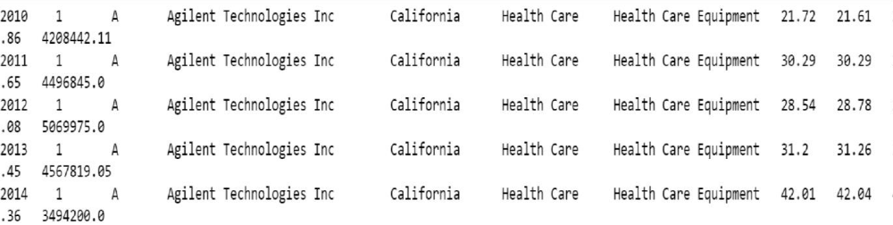

Analysis

1) Find the top five companies that are good for investment
create table stock_table1 as select company_name, min(trading_year) min_year, max(trading_year) max_year, min(trading_month) min_month, max(trading_month) max_month from stock_data group by company_name;

i)Next we find the growth percent for each company over the years
select stock_start.company_name, ((close-open)/open)*100 growth_percent
from(select t1.company_name, open from stock_data sd, stock_table1 t1
where sd.trading_year = t1.min_year and sd.trading_month = t1.min_month and sd.company_name = t1.company_name) stock_start, (select t1.company_name,
close from stock_data sd, stock_table1 t1
where sd.trading_year = t1.max_year and sd.trading_month = t1.max_month and sd.company_name = t1.company_name) stock_end where stock_start.company_name = stock_end.company_name sort by growth_percent desc limit 5;

Top 5 Companies by growth
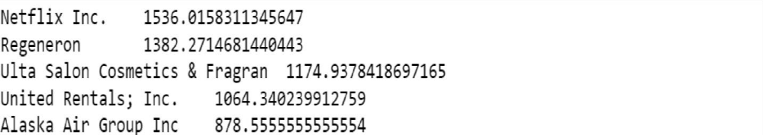
2)Show the best-growing industry by each state, having at least two or more industries mapped.

i)First we calculate the growth of companies belonging to every state and capital.
create table stock_table2 as select
state, sub_industry, stock_start.company_name, ((stock_end.close-stock_start.open)/stock_start.open)*100 growth_percent
from (select t1.company_name,open
from stock_data sd, stock_table1 t1
where sd.trading_year=t1.min and
sd.trading_month=t1.min_month and
sd.company_name=t1.company_name)stock_start,
(select t1.company_name, close
from stock_data sd, stock_table1 t1
where sd.trading_year=t1.max and
sd.trading_month=t1.max_month and
sd.company_name=t1.company_name)stock_end,
(select company_name, state, sub_industry
from stock_data
group by company_name,state,sub_industry)sd
where (stock_end.close-stock_start.open)>0 and
stock_start.company_name=stock_end.company_name and
sd.company_name=stock_start.company_name;
select * from stock_table2 limit 5;
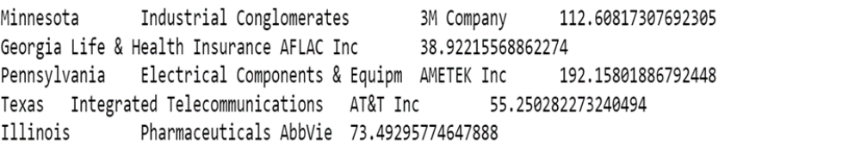
ii)Then we group by state and capital and filter industries listed atleast twice

create table stock_table3 as select state,sub_industry, avg(growth_percent)ind_growth from stock_table2 group by state, sub_industry having count(sub_industry>=2);
Select * from stock_table3 limit 10;
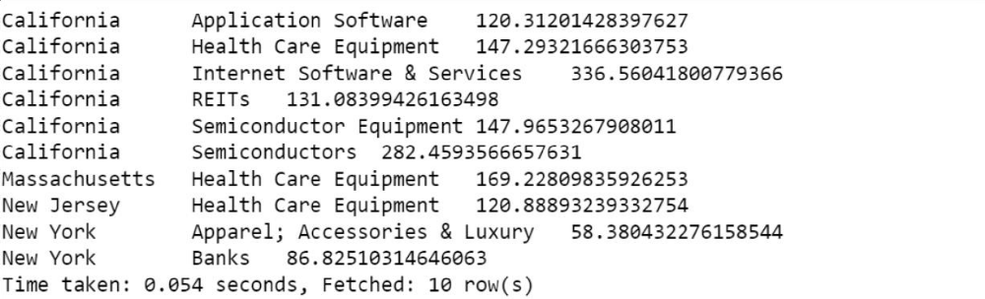

iii)Finally we find the industry which has maximum growth by each state

select t3.state, sub_industry, ind_growth from stock_table3 t3,
(select state,max(ind_growth) max_growth from stock_table3 group by state) max_ind where max_ind.state = t3.state and
t3.ind_growth = max_ind.max_growth;

best growing industry by each state
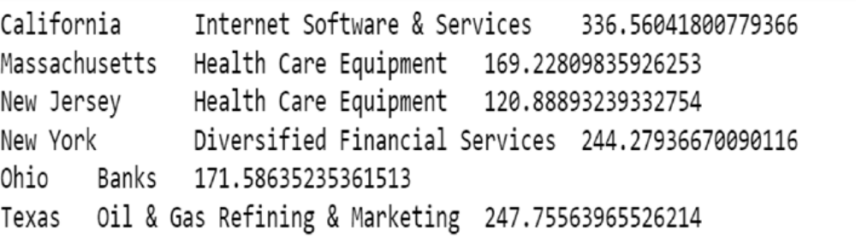
3) For each sector find the following.

• Worst year
• Best year

i)AS a first step we find the growth for each sector and year
create table stock_table4 as select open.sector, open.trading_year,
(close-open) growth from (select sector,trading_year,avg(open) open from stock_data where trading_month = 1 group by sector,trading_year) open, (select sector,trading_year,avg(close) close from stock_data
where trading_month=12 group by sector,trading_year) close
where open.sector = close.sector and open.trading_year = close.trading_year;

select * from stock_table4 limit 5;
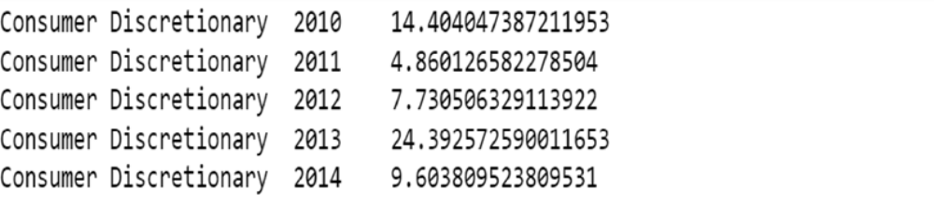

ii)In the year 2011, 3 sectors attained their new low

select x.sector,x.trading_year,x.growth from stock_table4 x,
(select sector,min(growth) growth from stock_table4 group by sector) y where x.sector=y.sector and x.growth=y.growth;

Year in which each of the sectors were worst hit
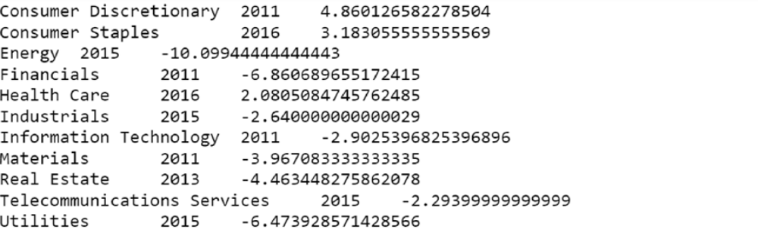

iii)In the year 2016 and 2014 most of the sectors enjoyed a very high growth.

select a.sector,a.trading_year,a.growth from stock_table4 a,

(select b.sector,max(growth) growth from stock_table4 group by sector) b where a.sector=b.sector and
a.growth=b.growth;

Best year for each sector
